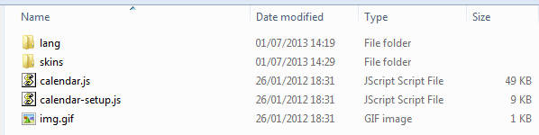

<link rel="stylesheet" type="text/css" media="all" href="js_calendar/skins/aqua/theme.css" title="win2k-cold-1" />

<script type="text/javascript" src="js_calendar/calendar.js"></script>

<script type="text/javascript" src="js_calendar/lang/calendar-en.js"></script>

<script type="text/javascript" src="js_calendar/calendar-setup.js"></script>